**Parametric Test**

Question: Is there difference in between the stroke and the smoke types.

* **One-way ANOVA Test:**

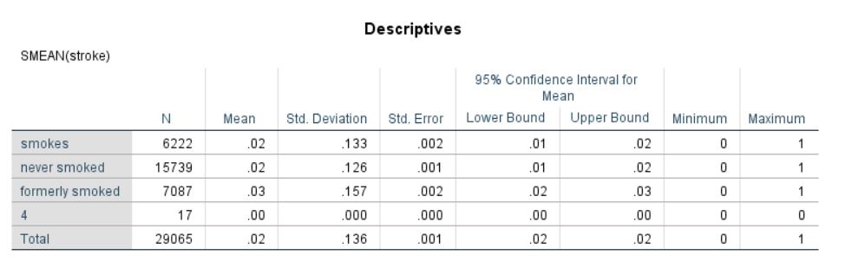

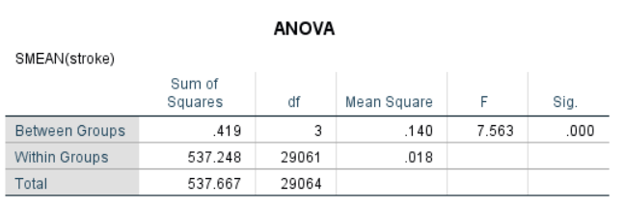

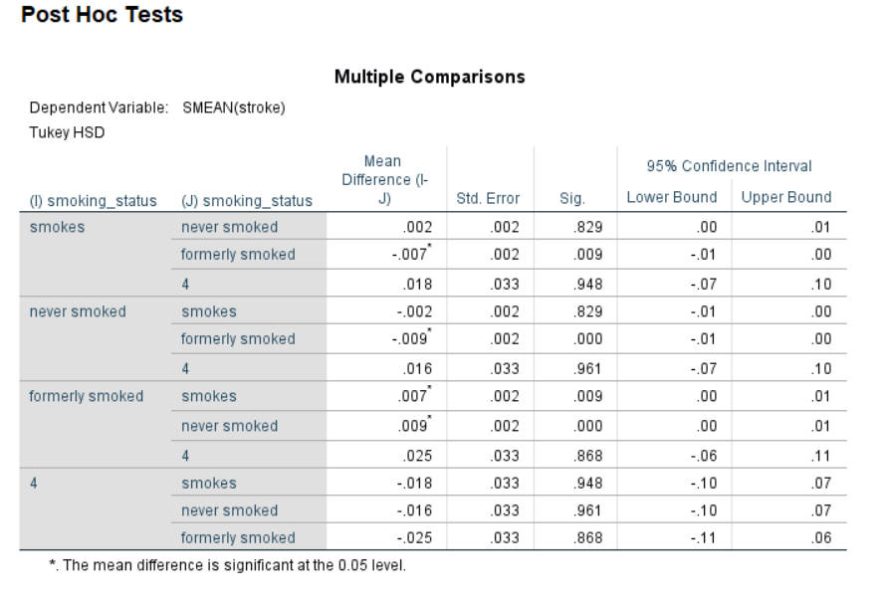

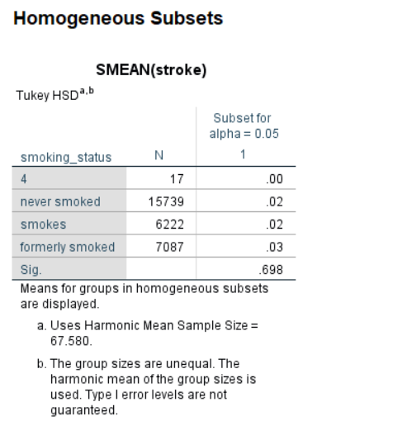

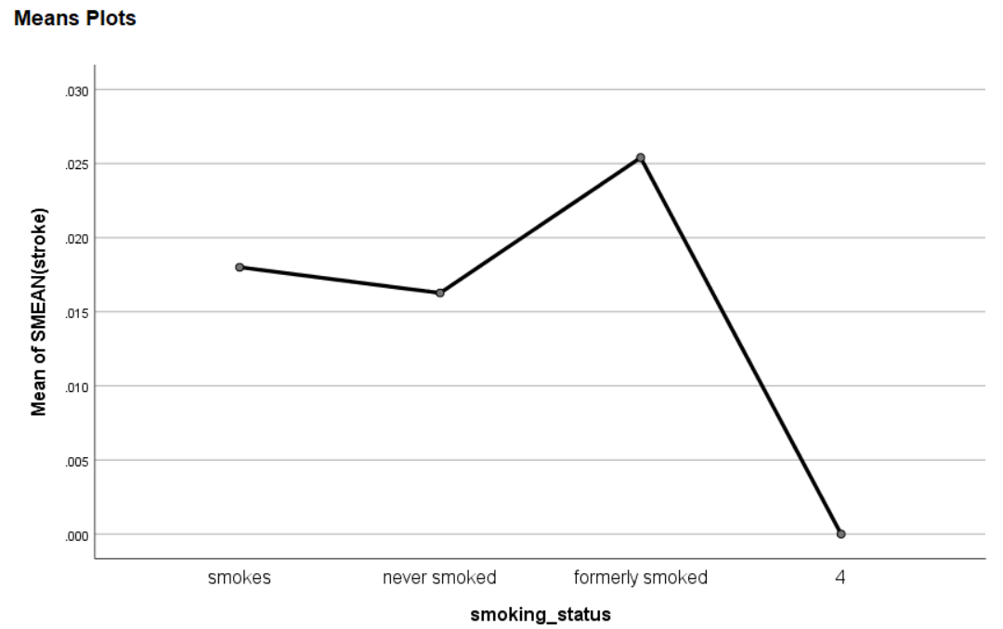

Based on the result, the p-value of the ANOVA test is less than the zero which indicates that the level of significance at 0.05 is more than the p-value (F3, 29064 = 7.563, p < 0.001). Thus, the null hypothesis can be rejected and support alternative hypothesis. Therefore, there is a significant difference in between the stroke and the smoke types.

On the other hand, the mean plot tells that is a visual representation of what we saw in the Compare Means output. The points on the chart are the average of each group. It's much easier to see from this graph that the never smokers had the slowest mean stroke, while the smokers had the fastest mean stroke.

Question: One specific medical program was carried out on medical students. Before medicine, the average glucose level of the university for that course was 106.4 for a day. The dean of the university would like to know the effectiveness of the medical program.

* **t-test:**

Null hypothesis: Mean = 106.4 (i.e., the difference in group means is 106.4)

Alternative Hypothesis: Mean does not equal to 106.4 (i.e., the difference in group means is not 106.4)

Output of the t-test:

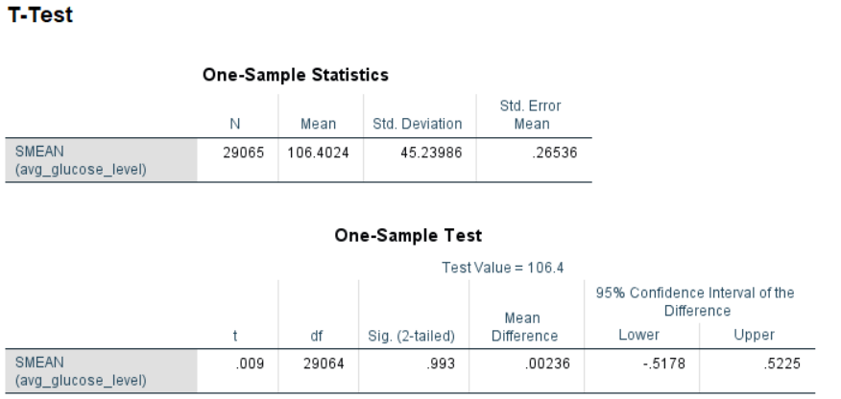

Based on the t-test output, the p-value of the test is 0.993, which is greater than the level of significance. So, we cannot reject the null hypothesis and do no support alternative hypothesis. Thus, there is a difference in group means is 106.4 and the medical program is effective for the university students.

Question: Is the mean difference between the paired average BMI and average hypertension is zero.

* **Paired Sample Test:**

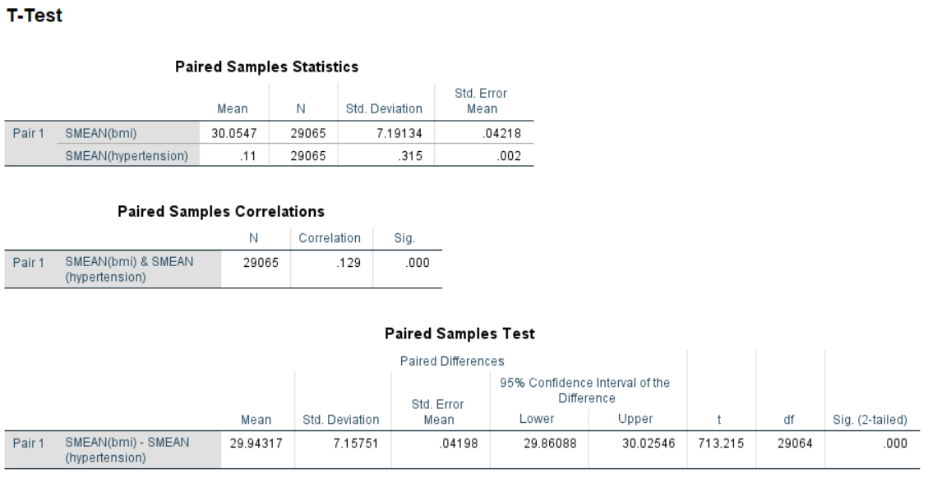

Based on the above paired t-test, the p-value of the test is 0.000 (or statistically significant) which is less than the level of significance i.e., 0.00 < 0.05. It can be easily concluded that there is no mean difference between the paired average BMI and average hypertension which is different from zero. Additionally, the correlation between the BMI and the hypertension is positive but not very much strong i.e., r = 0.13.

**Power and Effect Size Test (Cohen’s d):**

Question: Is there is a relationship between the average glucose and gender (male and female).

Output of the test:

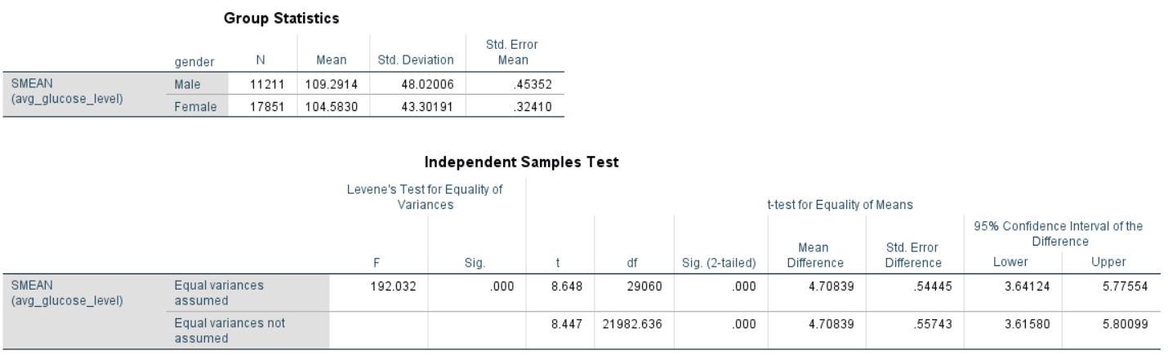

The p-value of the test is close to zero and the level of significance is 0.05 which indicates that the p-value of the test is lower than the alpha level. Based on the evidence, the null hypothesis can be rejected and in support of an alternative hypothesis. Therefore, the is a significant difference in between the average of glucose and gender.

On the other hand, the Cohen's d is the appropriate effect size measure for two groups. Here is the calculation of the d:

Cohen's d = (104.583 - 109.2914) ⁄ 45.720949

= 0.102981.

In this case, the value of d is 0.10, which indicates that there is a small effect between the groups.